**Jeremy Rios-Martinez**

**COMSC 265**

**Lab 78**

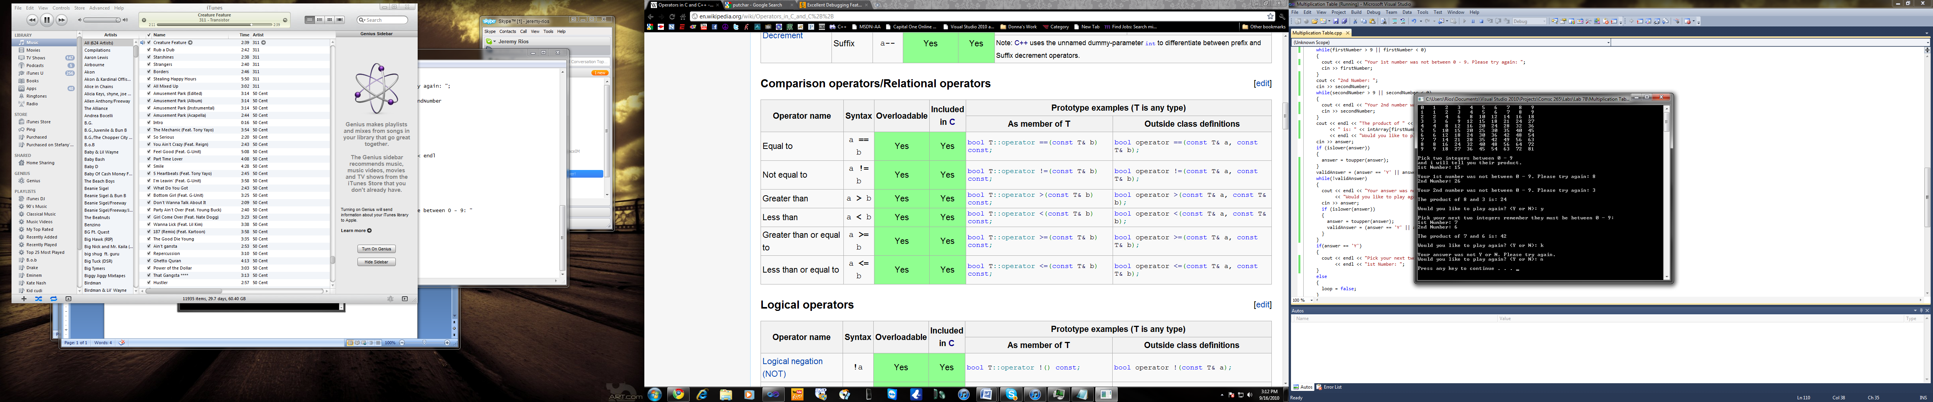**Exercise 1 print out**

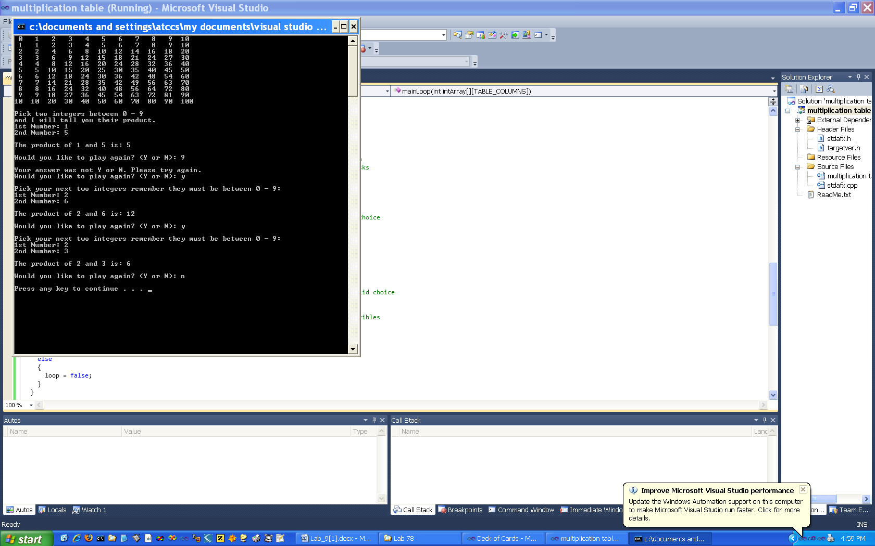

**Exercise 2 print out**

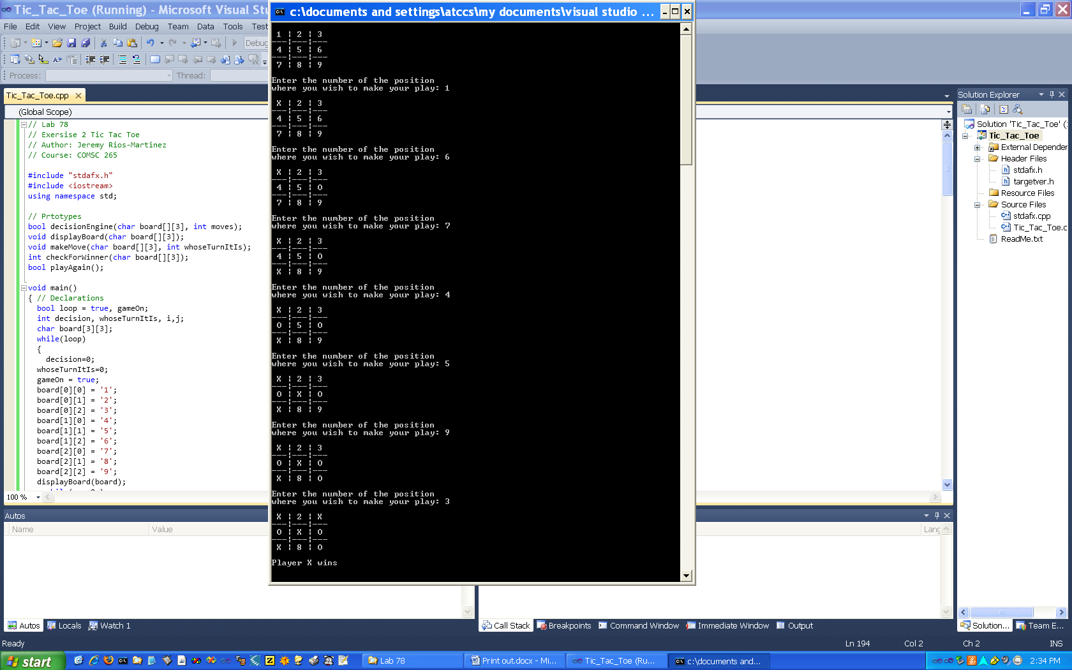

**Exercise 3 print out**

